## Pre-requisite for ReactJS

1. NodeJS and NPM
2. React and React DOM
3. Webpack
4. Babel

## Ways to install ReactJS

There are two ways to set up an environment for successful ReactJS application. They are given below.

1. Using the npm command
2. Using the create-react-app command

### 1. Using the npm command

**Install NodeJS and NPM**

**NodeJS and NPM are the platforms need to develop any ReactJS application. You can install NodeJS and NPM package manager by the link given below.**

1.2M

To verify NodeJS and NPM, use the command shown in the below image.

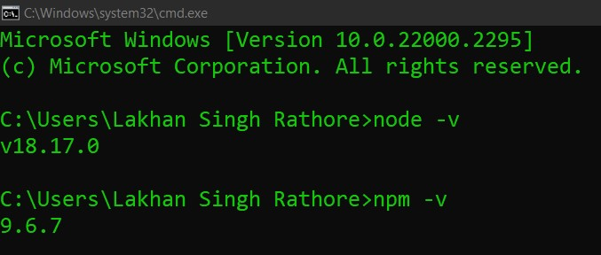

**Install React and React DOM**

Create a **root** folder with the name **reactApp** on the desktop or where you want. Here, we create it on the desktop. You can create the folder directly or using the command given below.

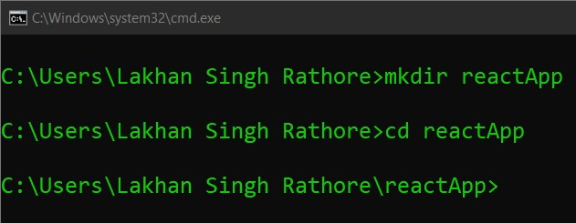

Now, you need to create a **package.json** file. To create any module, it is required to generate a package.json file in the project folder. To do this, you need to run the following command as shown in the below image.

*C:\Users\Lakhan Singh Rathore\reactApp>npm init -y*

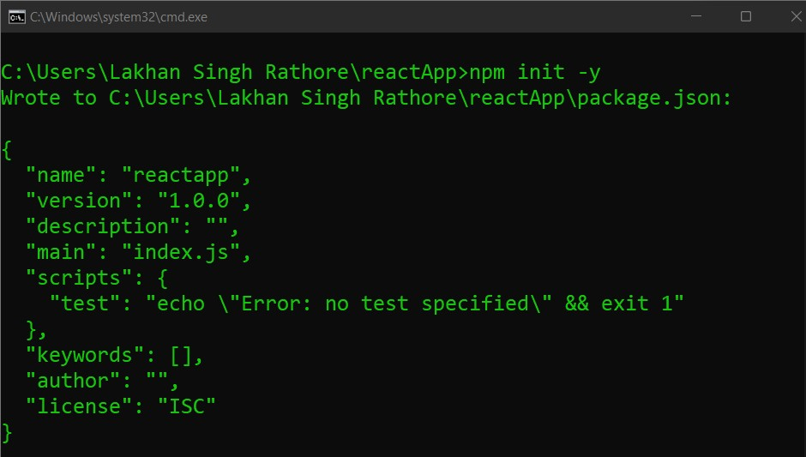

After creating a package.json file, you need to install **react** and its DOM **packages** using the following npm command in the terminal window as shown in the below image.

C:\Users\Lakhan Singh Rathore\reactApp>npm install react react-dom --save

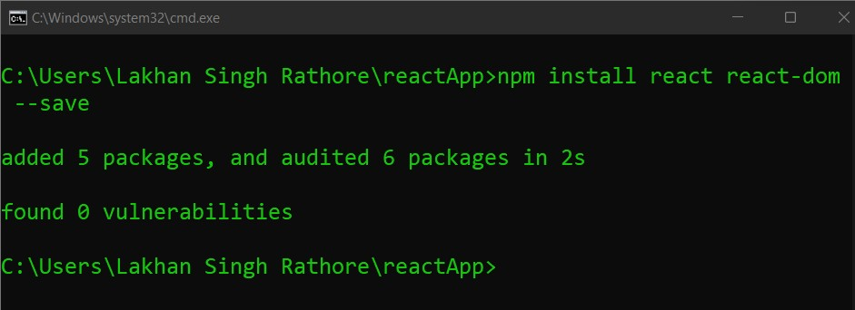

You can also use the above command separately which can be shown as below.

**Starting Server:-**

